Task 1. Create an index on the actual_departure colum

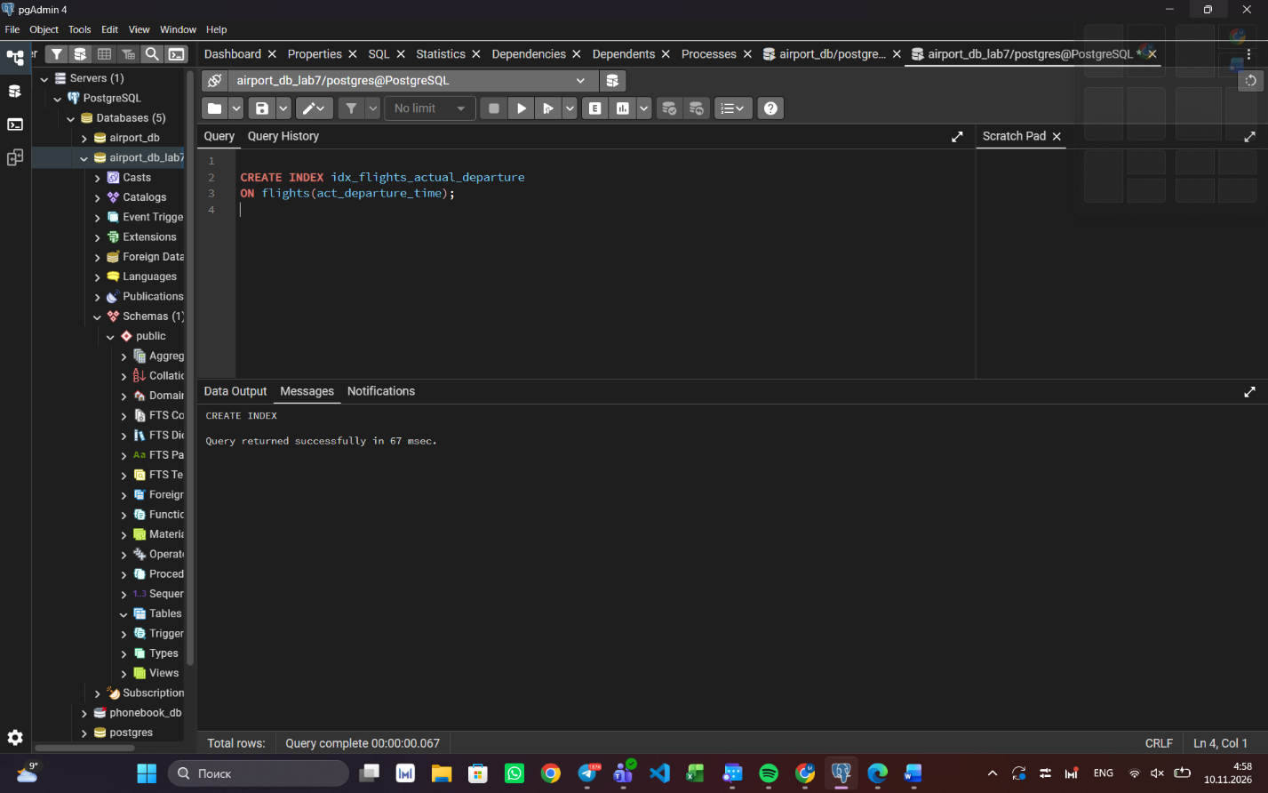

Task 2. Create a unique index
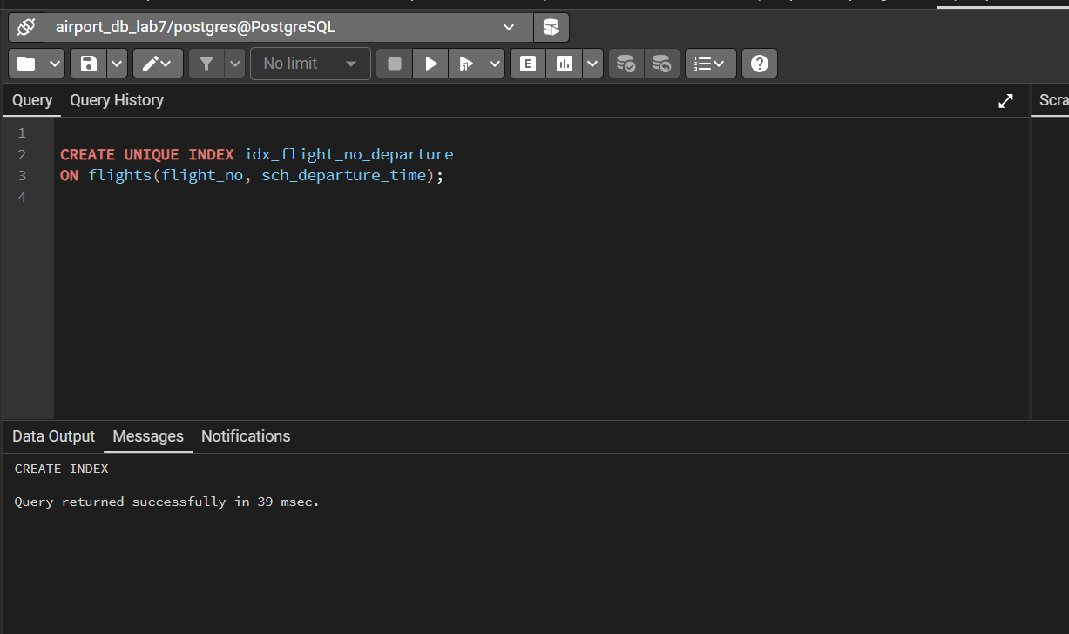
Task 3. Create a composite index
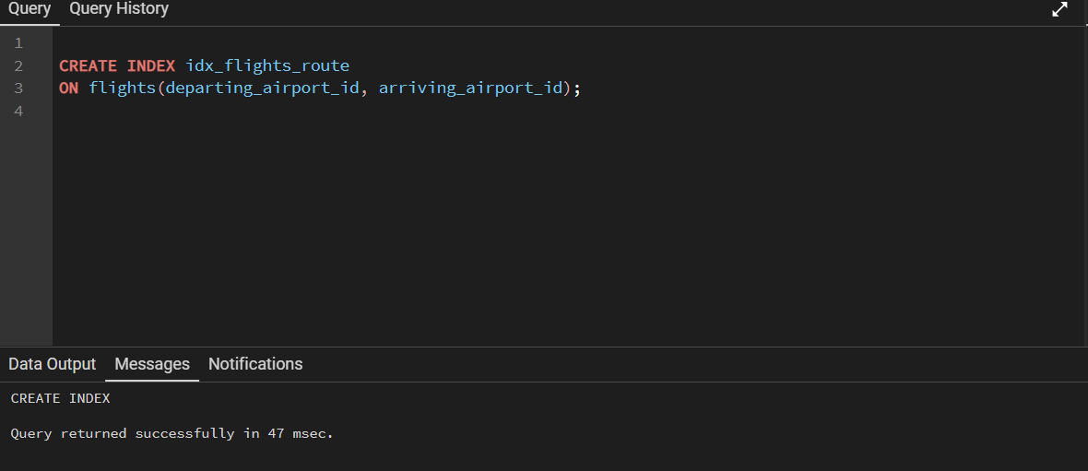

Checking all of the indexes
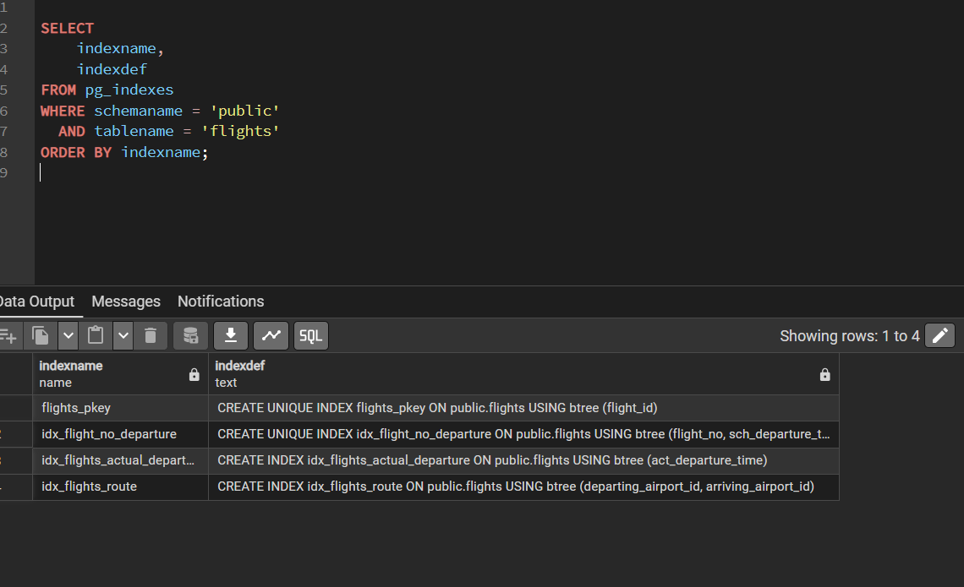

Task 4 — Compare query performance
With index
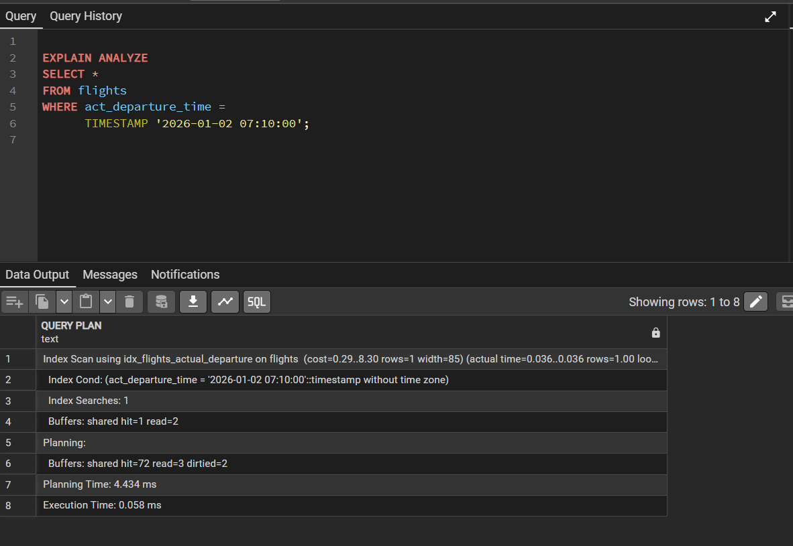

Without index
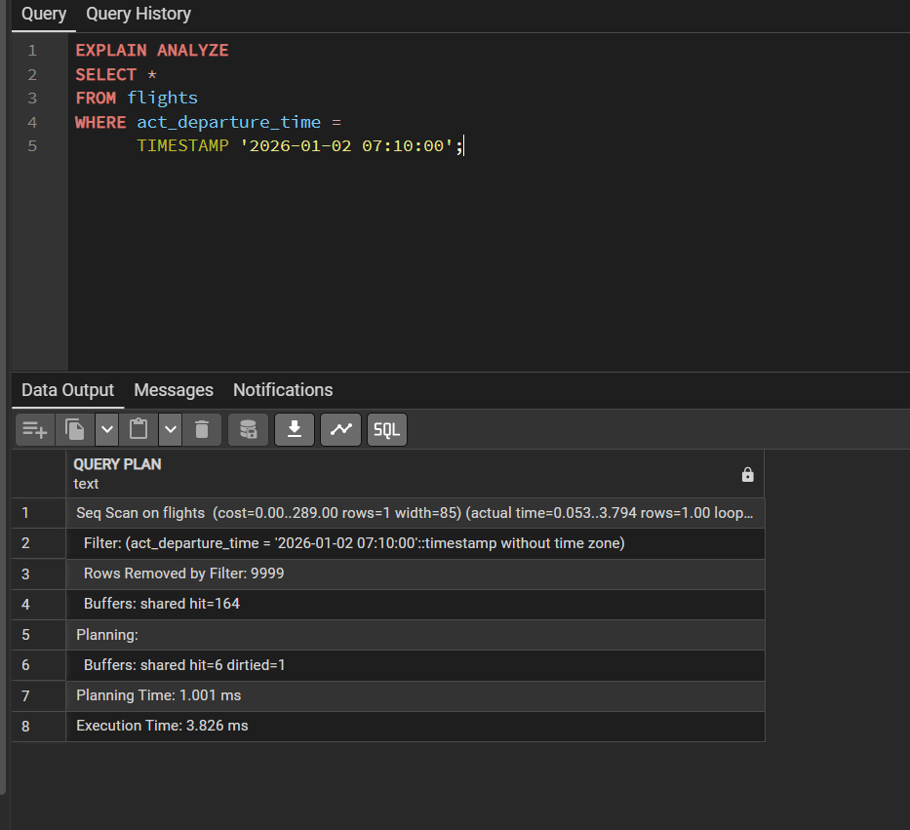

Use EXPLAIN ANALYZE to check index usage in a query filtering by
departure_airport and arrival_airport.

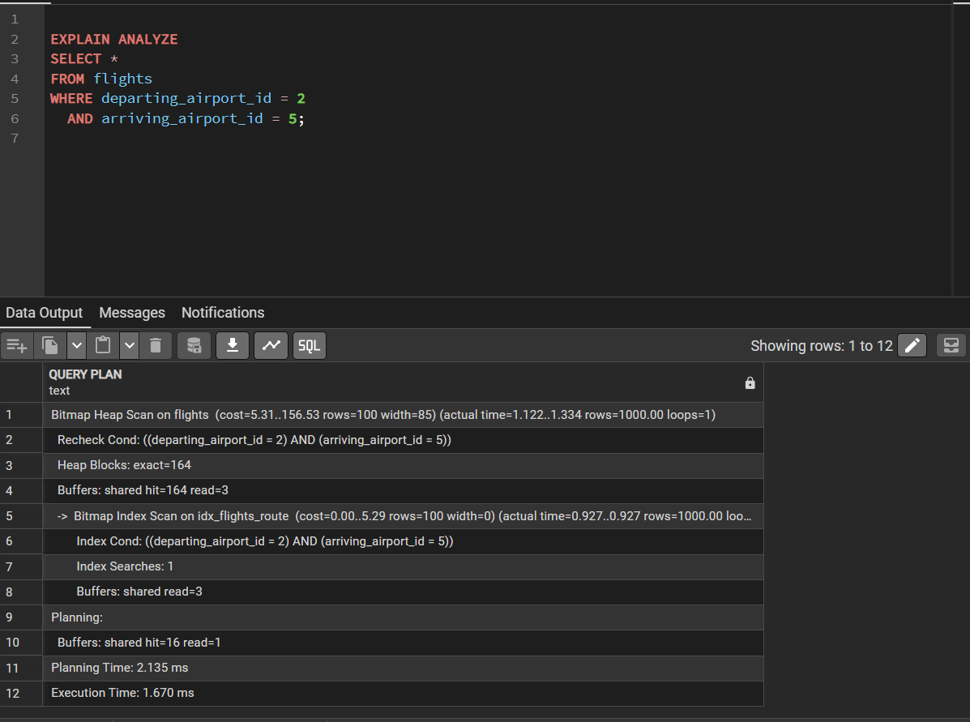

- Create a unique index for the passport_number of the Passengers table. Check if the index was created or not. Insert into the table two new passengers. Explain in your own words what is going on in the output?
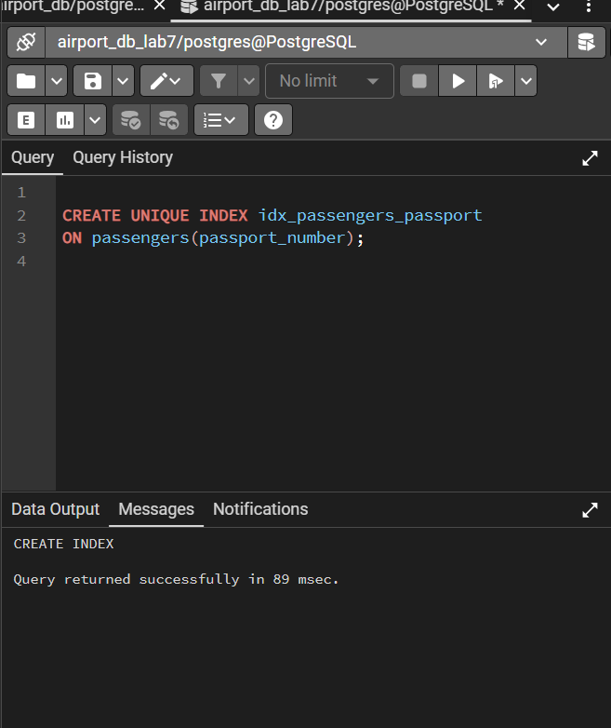
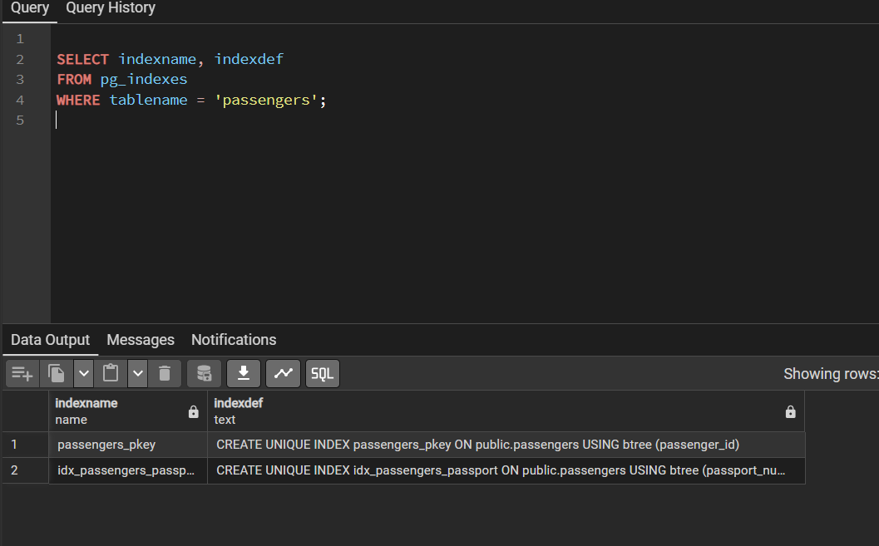
Added 2 passengers
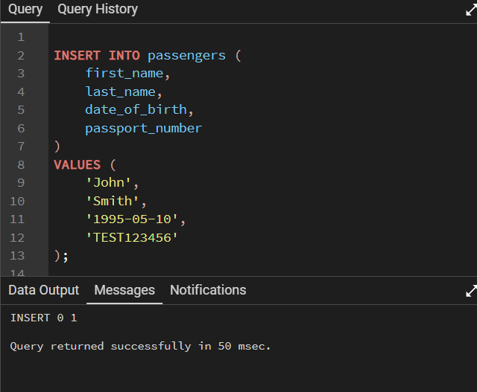
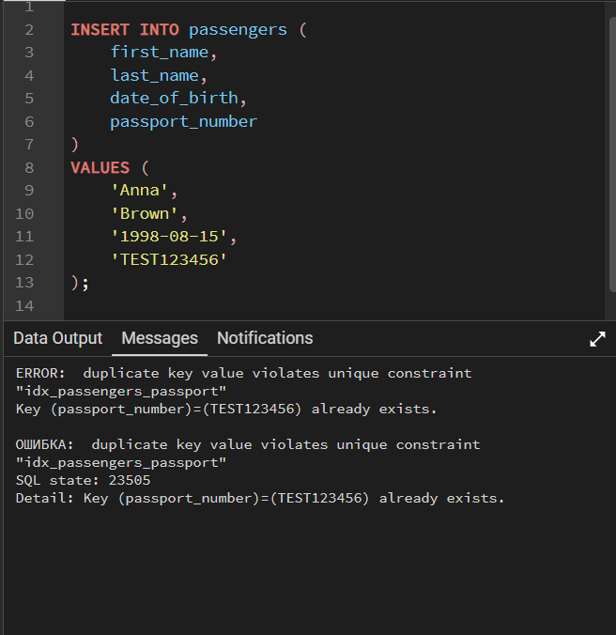
PostgreSQL returned a duplicate key error because the unique index prevents duplicate values in the passport_number column.

- Create an index for the Passengers table. Use for that first name, last name, date of birth and country of citizenship. Then, write a SQL query to find a passenger who was born in Philippines and was born in 1984 and check if the query uses indexes or not. Give the explanation of the results.
Created and index for passengers
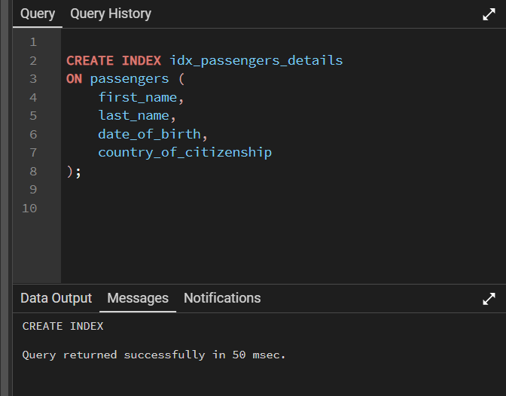
Searhcing for Phillipines 1984
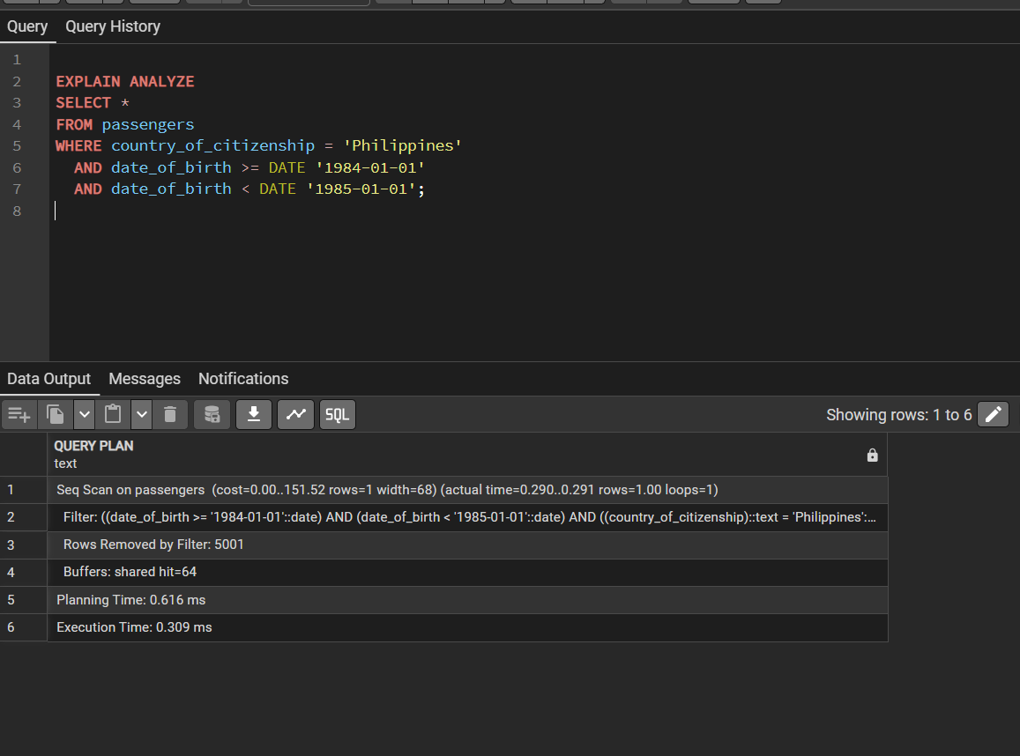

- Write a SQL query to list indexes for table Passengers. After delete the created indexes.
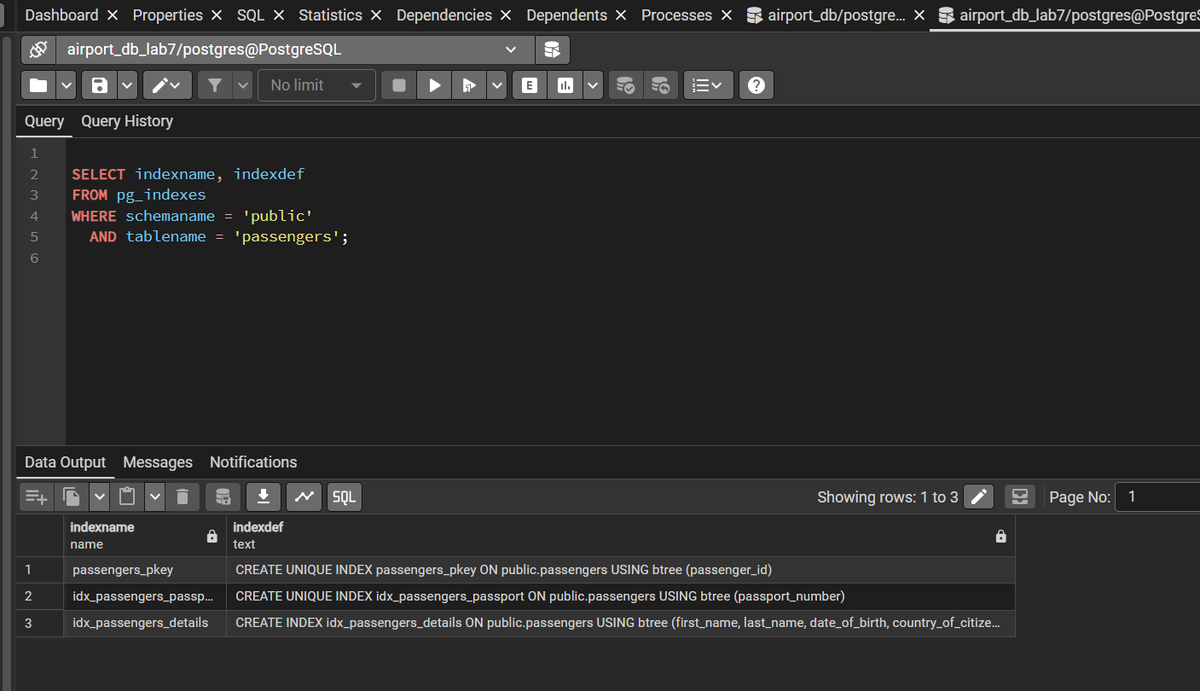

Deleted index
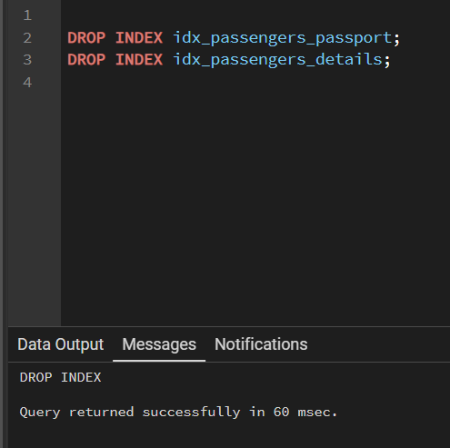

After delete
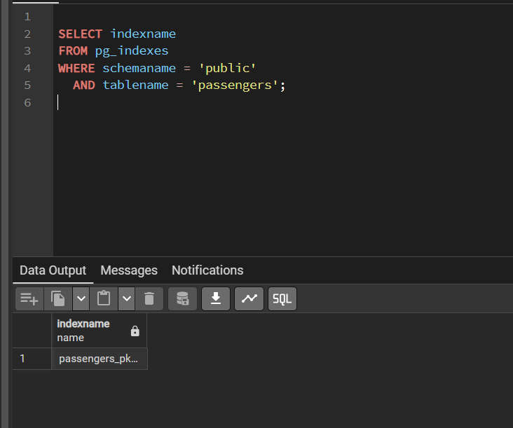

- Create an index on the passenger_id column of the booking table. Using EXPLAIN ANALYZE, compare the execution plan and execution time of a query that selects all bookings of one passenger (for example, passenger_id = 100) before and after creating the index. Explain what changed in the plan.
Before the index
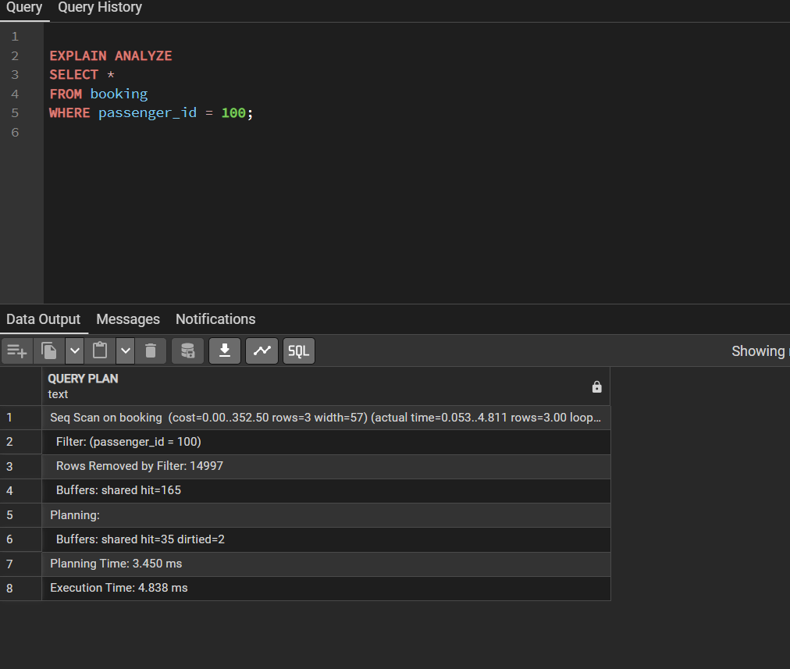
After the index
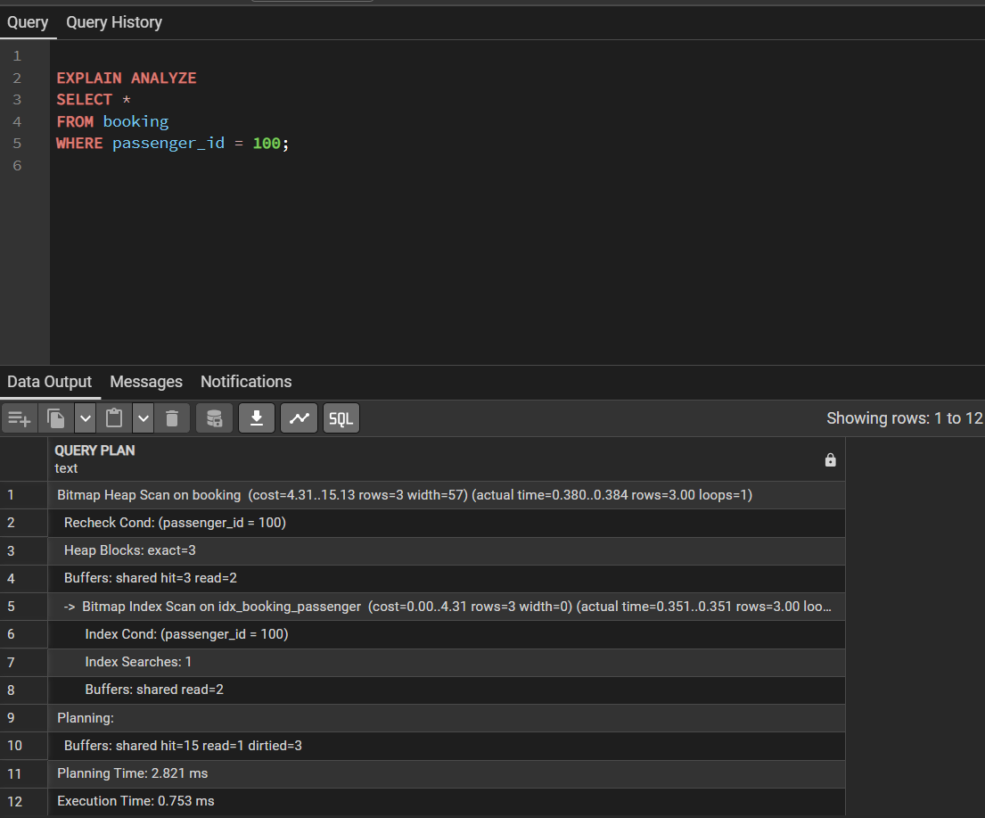
- Create a composite index on the booking_flight table using the booking_id and flight_id columns. Write a query that joins booking, booking_flight and flights and returns the flight_no and price for bookings with a price greater than 9000. Check with EXPLAIN ANALYZE which indexes are used in each step of the join.
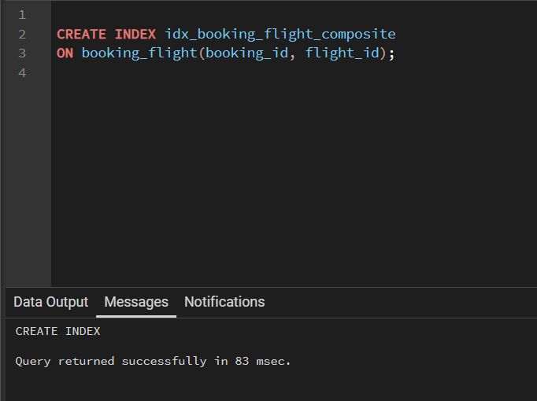
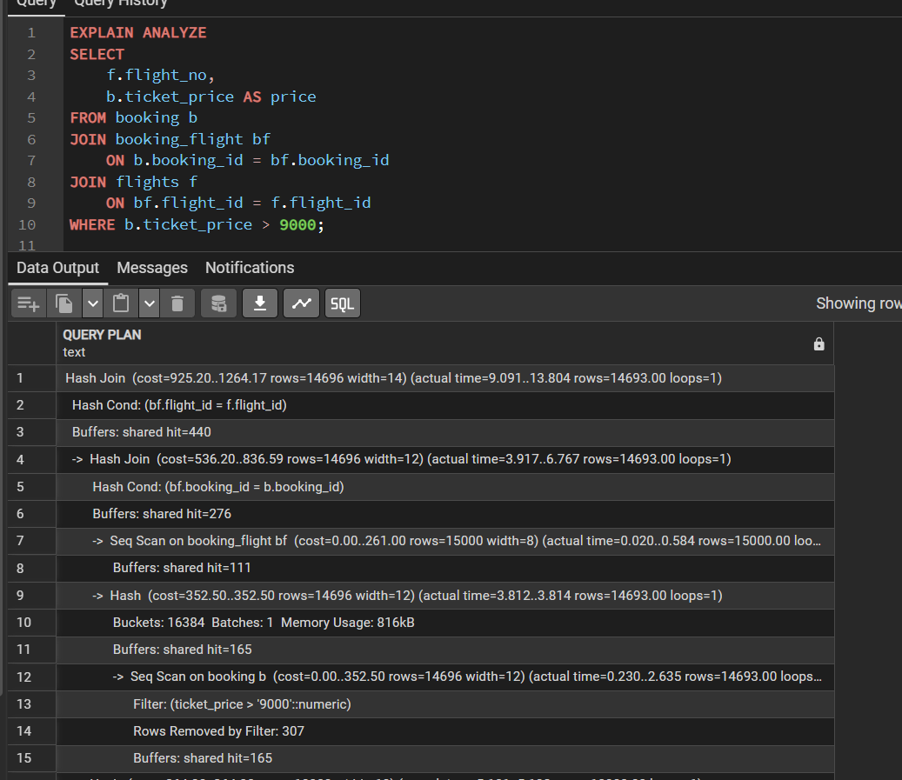
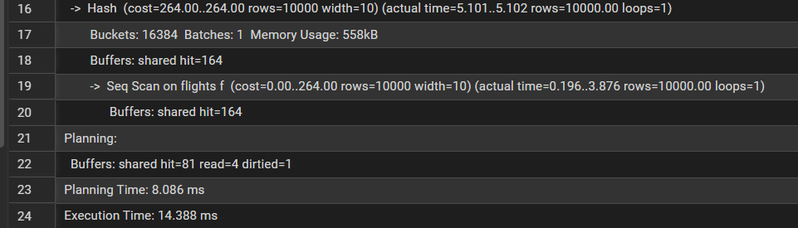
- Create an index on the status column of the flights table. Run EXPLAIN ANALYZE for the query with status = 'Departed' and for the query with status = 'Boarding'. Compare the plans and explain, in your own words, why the optimizer may ignore the index for one of the values (hint: selectivity).

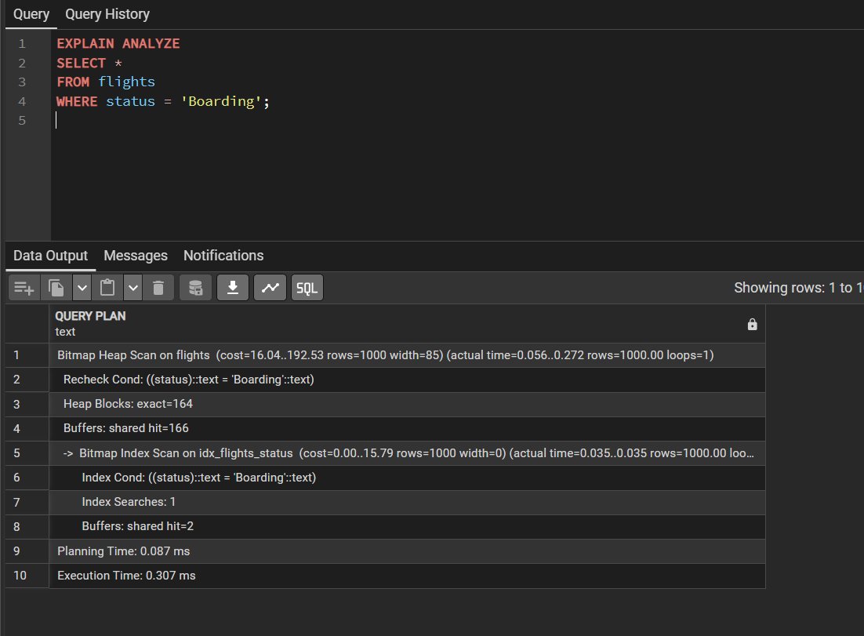

- Create an index on the weight_in_kg column of the baggage table. Compare the plans of two range queries: weight_in_kg > 49 (a small part of the table) and weight_in_kg > 5 (almost the whole table). Explain the difference in index usage.
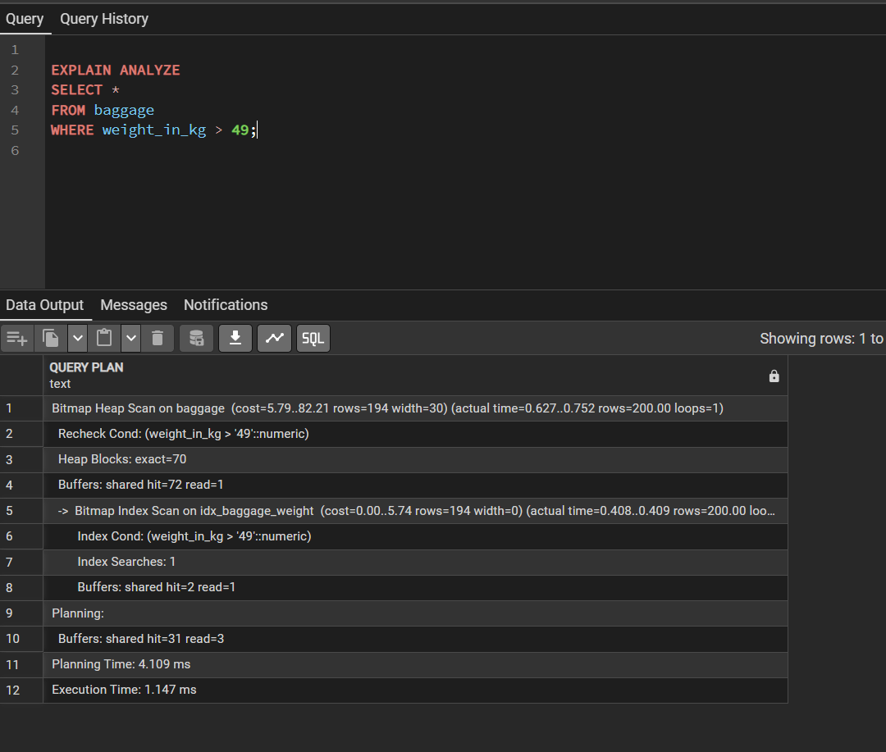

- Create an index on the airport_name column of the airport table. Check with EXPLAIN ANALYZE whether it is used by the queries LIKE 'A%' and LIKE '%Airport'. Explain why the results are different.
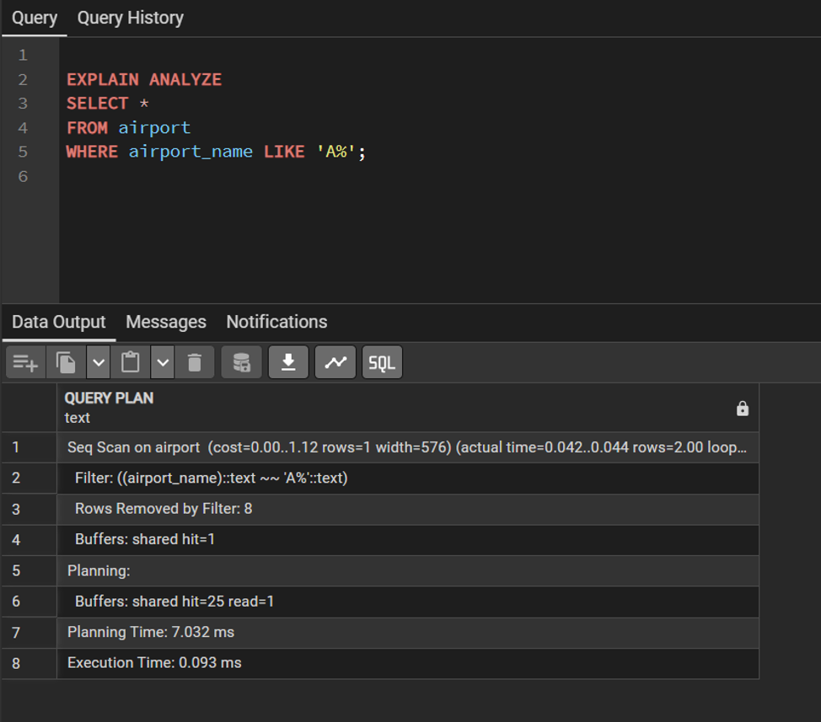

An index was created on the airport_name column of the airport table.
For LIKE 'A%', PostgreSQL used a Sequential Scan. The query returned 2 rows, and the execution time was 0.093 ms.
For LIKE '%Airport', PostgreSQL also used a Sequential Scan. The query returned 10 rows, and the execution time was 0.256 ms.
A prefix search such as LIKE 'A%' can potentially benefit from a suitable B-tree index, while LIKE '%Airport' has a leading wildcard and cannot efficiently use a regular B-tree index.
In this case, PostgreSQL chose Sequential Scans for both queries because the airport table contains only 10 rows.

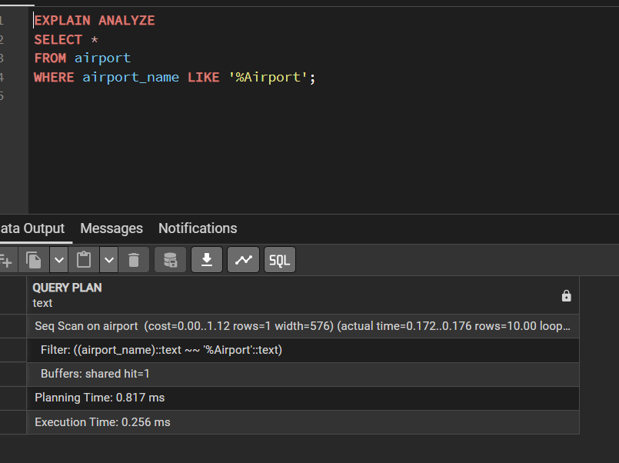
- Create a composite index on the country and city columns of the airport table. Run three queries: filtering by country only, by city only, and by both columns. Check which of them use the index and explain the leftmost prefix rule using your results.
Country only
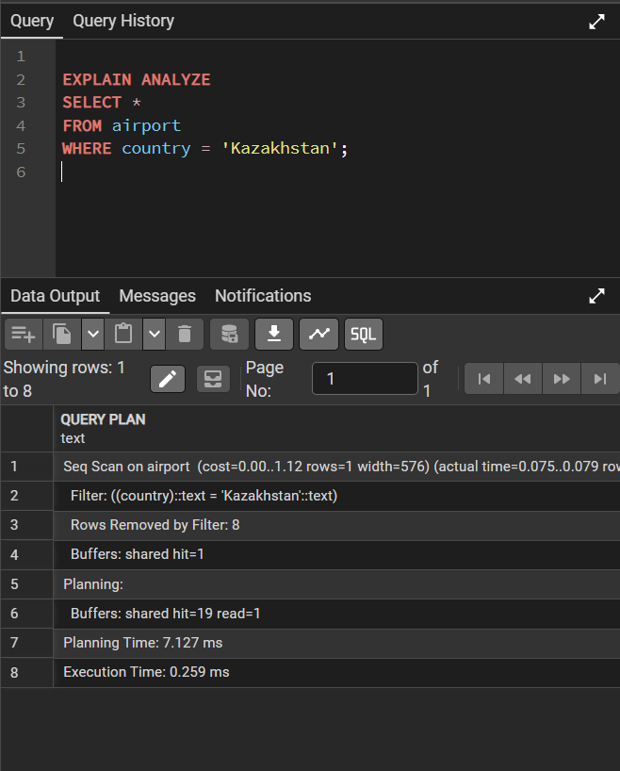
City only
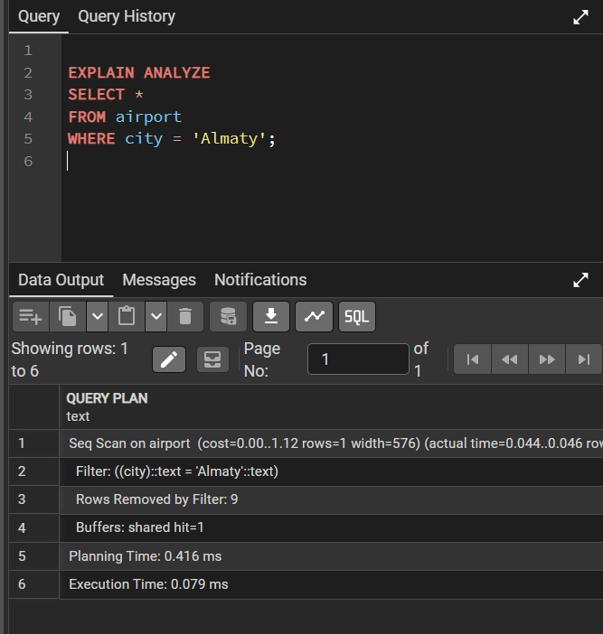
County+city
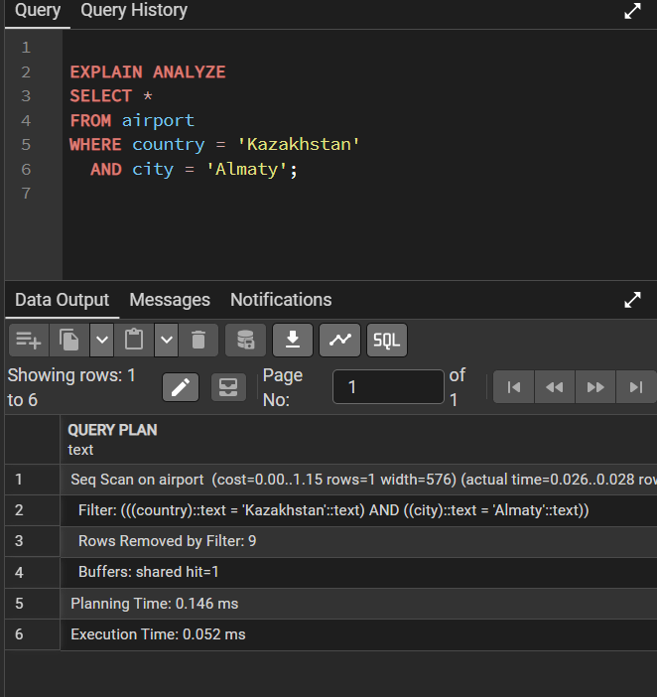
15 Create an expression (functional) index on the lower-case last_name of the Passengers table (LOWER(last_name)). Compare the plans of a query written as WHERE LOWER(last_name) = 'irnis' and a query written as WHERE last_name = 'Irnis'. Explain which query can use the index and why.

With lower snd no lowr
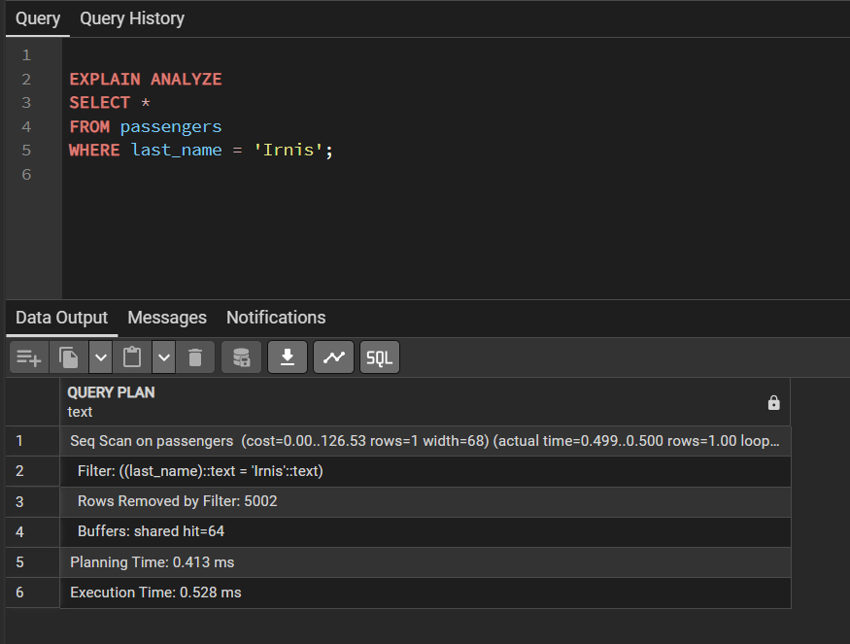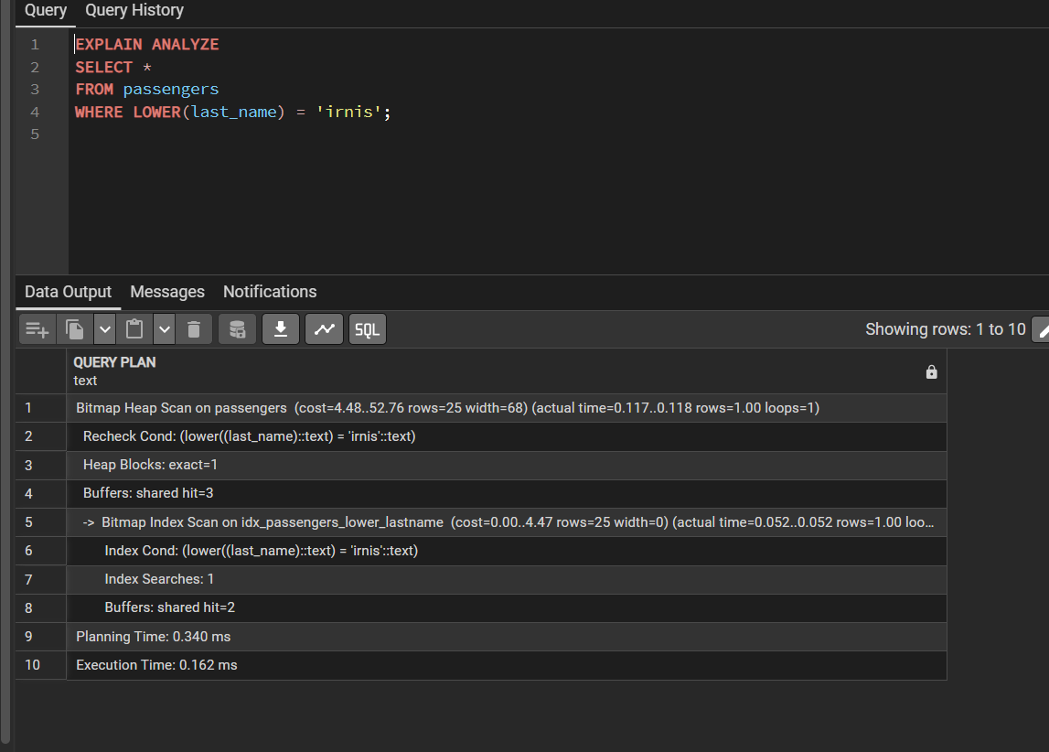
  - Create a covering index on the booking table for the columns passenger_id and price. Write a query that returns only price for a given passenger_id and check with EXPLAIN ANALYZE whether an index-only scan (or "Using index") is used. Explain the benefit of a covering index.
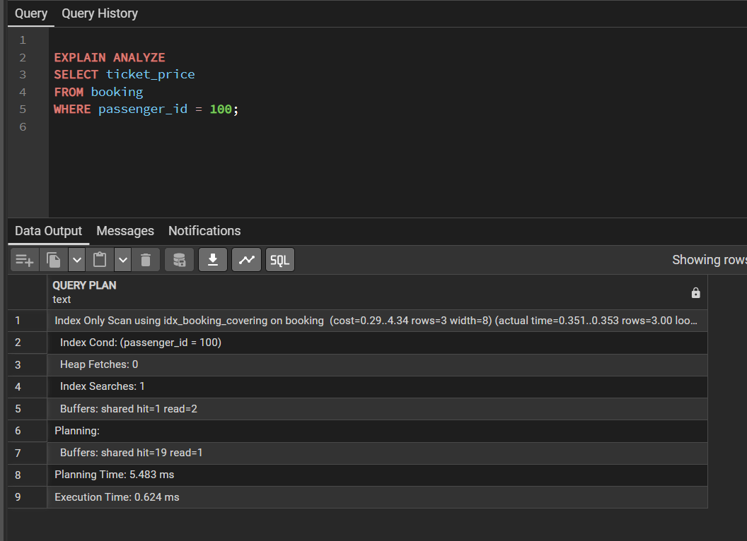

17 Try to create a unique index on the airline_code column of the airline table. If an error occurs, explain what caused it and find the problematic rows with a GROUP BY ... HAVING COUNT(*) > 1 query. Then create the unique index in a way that works for the current data, or after fixing the data.


